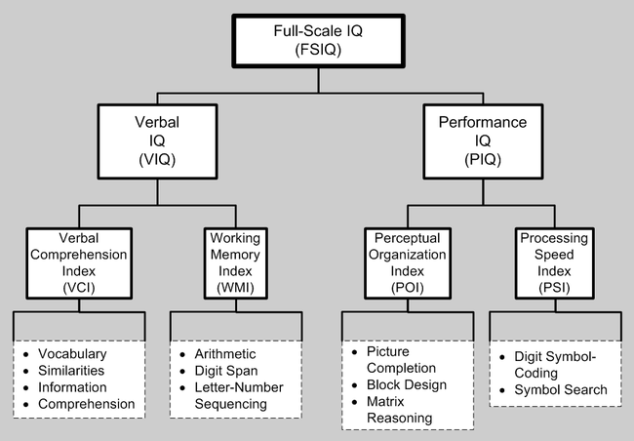

Assignment steps:

1. Regular CFA – does the factor structure for the WAIS hold up?
   1. Test the following models
      1. Program 4-factor model – with the indices as latent variables
      2. Program 2-factor model – with the IQs as latent variables (collapse across the indices for those latents)
      3. Program 1-factor model – with IQ as the only latent variable.
   2. Be sure to include the following:
      1. Fit indices table – for ALL models.
      2. X2 difference test against the proposed 4-factor model
      3. Which model is best?
   3. For the BEST MODEL ONLY:
      1. Check the standardized residuals and see if there are any questions that are not being measured well (i.e. residual > 2.58)
         1. Report those questions and values
      2. Should any of the questions be moved? Check the modification indices and report if you moved or double loaded questions.
2. Assessment of assumptions (for the BEST MODEL ONLY):
   1. Are your data normal (list skew and kurtosis values for the HIGHEST questions)?
   2. Are your data multivariate normal (report the multivariate normality score)?
   3. Are there are outliers? How many?
3. Second order CFA – on a 2-factor or 4-factor model only (if the best model is the one factor, you will need to program the second order on something with multiple factors)
   1. Program an general IQ factor leading to your subscale factors
   2. List model fit.
   3. Run this analysis with Bayes estimation.
      1. Compare at least 3 of the raw score estimates to the Bayes score estimates (put in a table).
      2. Which would you say was better (look at the SE values)?
4. Full SEM – program the following model:
   1. Use modification indices to make a better model (that still makes sense!)
   2. List all fit indices and chi square differences as you change paths
   3. Are there any non-significant paths
   4. Check out the standardized estimates (make sure no heywood cases!)
   5. How much variance is accounted for by each of the latents (use SMCs).
5. Be sure to include:
   1. Write up of all the models.
   2. Pictures of all models.
   3. Fit indices of all models.
   4. Residuals/modification stuff, assumptions scores, outliers